Module 2 Week 3 Assignment: Use of Dynamic Analysis Tools
02/08/2026
Danny LeBlond
CNG4054X00 Malware Threats and Analysis

Dynamic Analysising file Lab03-01.exe
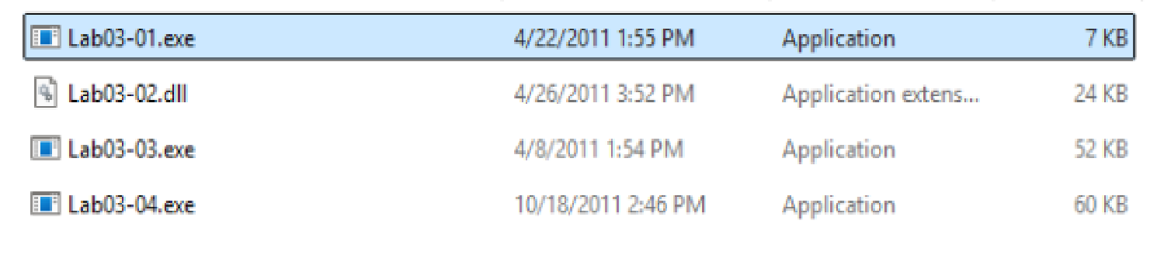

Regshot:
Regshot base line (1st shot):
This screenshot shows Regshot being used to take the first registry snapshot before the malware file is opened. At this point the system is clean and nothing weird has been run yet. The main reason for this first snapshot is to create a baseline. A baseline is basically a before picture of the Windows registry so it can compare it later. This step is important because malware often changes the Windows registry when it runs. Practical Malware Analysis explains that malware often modifies the Windows Registry by creating, changing, or deleting keys and values to support execution and persistence (Sikorski & Honig, 2012, Chapter 3). By taking this first snapshot (1st shot) it becomes easier to see exactly what changed after the malware is executed by the tool. Without this baseline screenshot, it would be very hard to tell which registry changes were caused by the malware versus normal system activity.
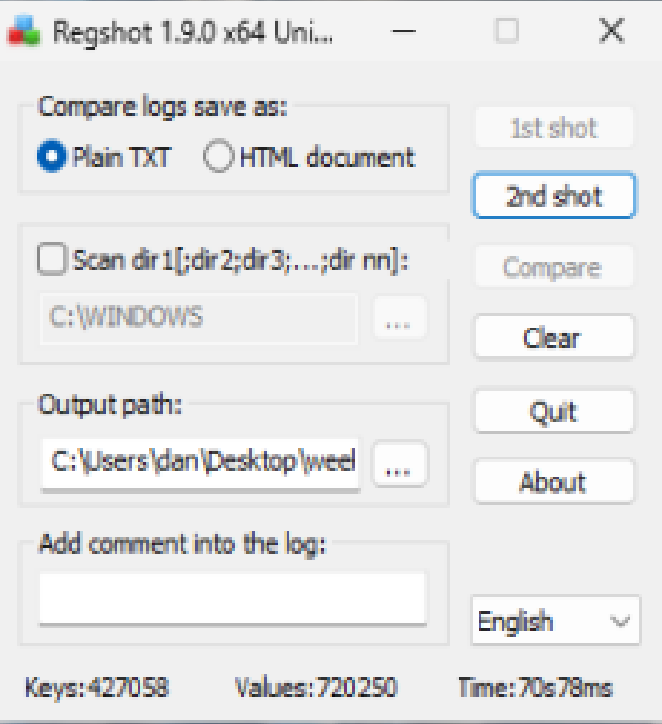

Regshot malware run (2nd shot/compare):
This set of screenshots show the results from Regshot after the malware was ran. After running the malware a second registry snapshot was taken and compared to the first one by the regshot tool. This makes it easier to see what changed on the system after the malware executed.
These screenshots are important because they show how the malware interacted with the Windows registry. Malware often uses the registry to save information, keep track of activity, or work with system features (Sikorski & Honig, 2012, Chapter 3). The changes are grouped into categories like keys deleted, values deleted, values modified, and keys added. Each screenshot below focuses on one type of registry change. When all of them are looked at together they will help give a clearer understanding of what the malware did while it was running.

Keys Deleted:
This screenshot shows registry keys that were deleted after the malware was run. When registry keys are deleted, it can mean the malware cleaned up after itself or removed temporary information once it finished running. Several of the deleted keys are related to Windows Error Reporting, which is a Windows feature that records application crashes, process failures, and system errors (Microsoft, Windows Error Reporting). This suggests the malware caused errors or made processes stop while it was running.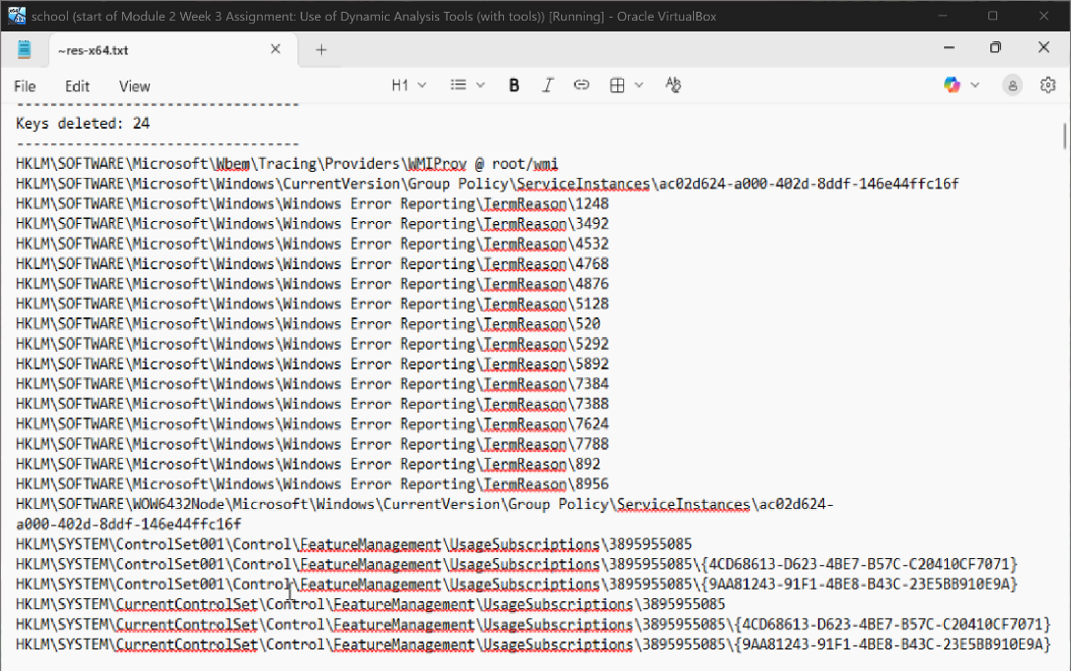
Key added:
This shows the malware did more than just open and close. It actively changed the system while it was running, which confirms it had an impact on the computer.
This screenshot shows new registry values that were added after the malware was run. These new values are related to application activity, process details, and system events. Microsoft documentation explains that these parts of the Windows registry are used to store information about program execution, system behavior, and application usage (Microsoft, Windows Registry). When malware adds registry values, it is usually saving information about what it did or keeping track of its activity while it was running (Sikorski & Honig, 2012, Chapter 3).
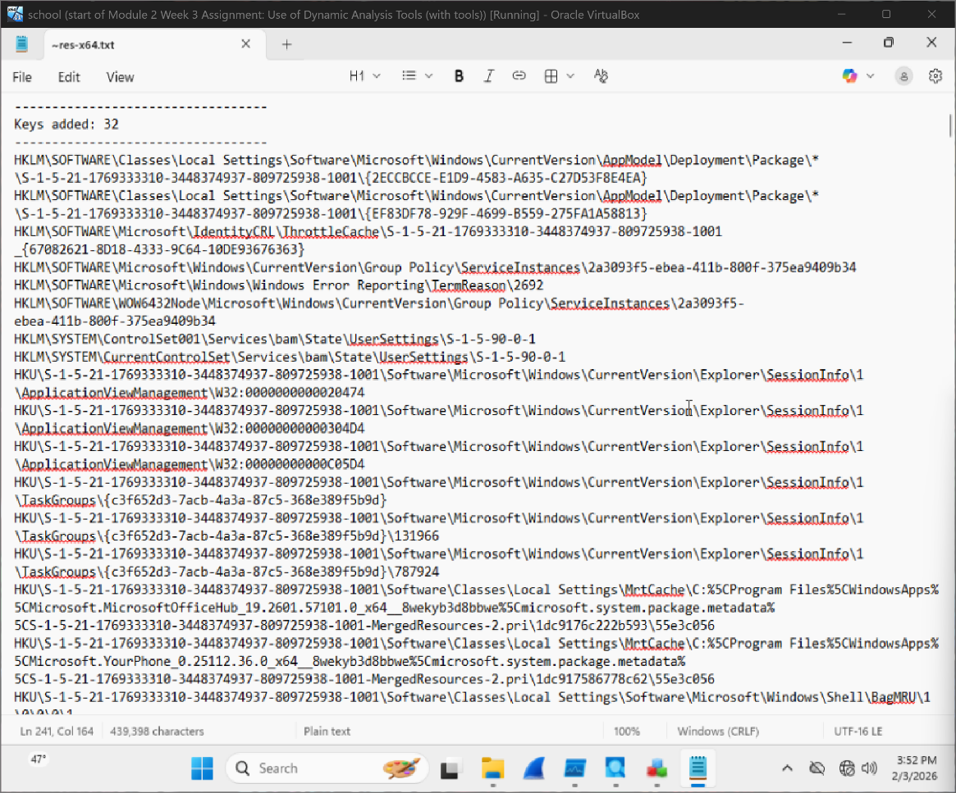

Values deleted:
This screenshot shows registry values that were deleted after the malware was run. Many of these values are linked to Windows Error Reporting and information about programs stopping or crashing. This likely means the malware caused some processes to end, which made Windows create logs and then remove them later. When malware deletes registry values, it can be a way to clean up after itself. By removing these the malware makes it harder to see exactly what happened after it ran.
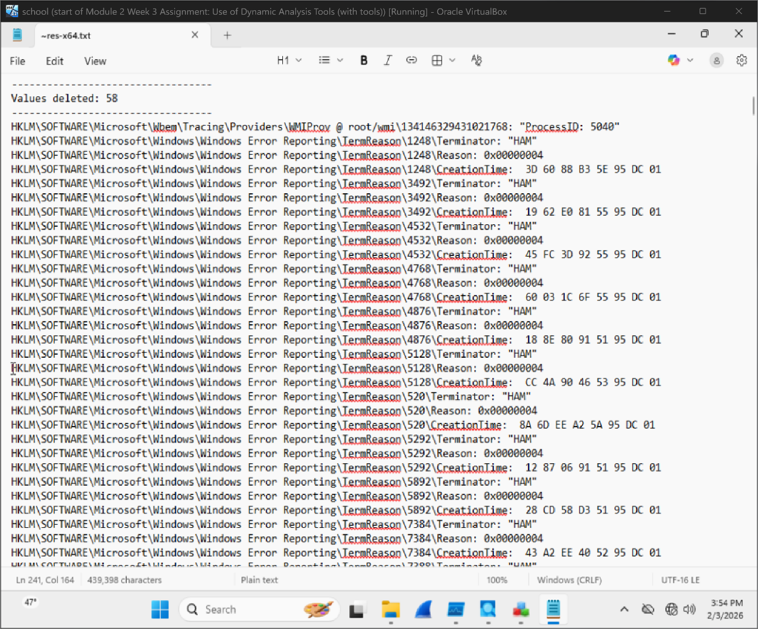

Values added:
This screenshot shows new registry values that were added after the malware was run. These values are connected to application activity, process details and system events. When malware adds registry values it is normally is trying to saving information about what it did or keeping track of what it did so it know where its at.
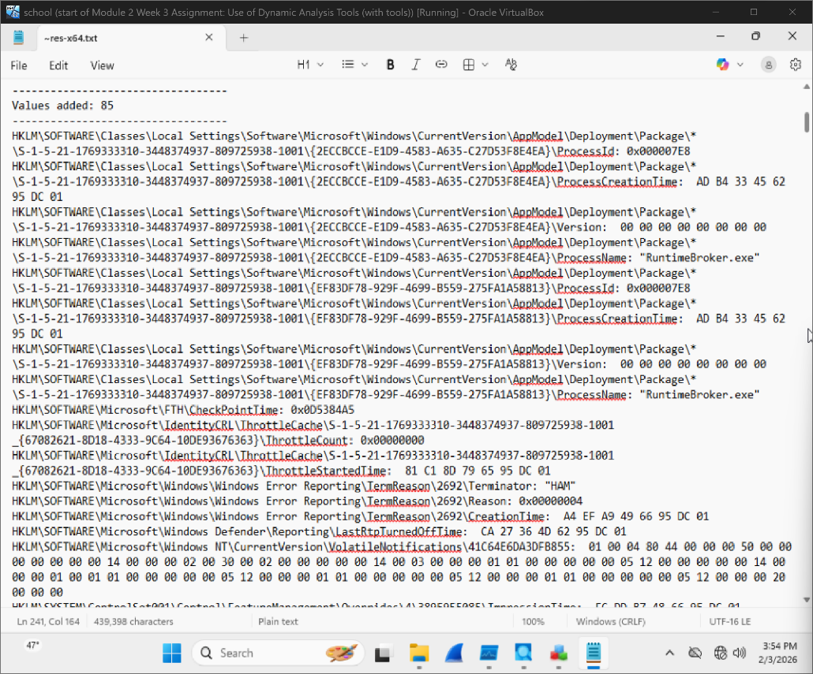

Values Modified:
This screenshot shows registry values that were changed while the malware was running. Modified values mean the malware edited information that was already there instead of making brand new ones. Many of these changes are connected to Windows diagnostics and tracking features, like DiagTrack. Microsoft explains that Windows uses diagnostic data to record system activity, how programs behave, and system events (Microsoft, Windows Diagnostic Data). By changing existing registry values malware can change how the system works or how activity is logged.
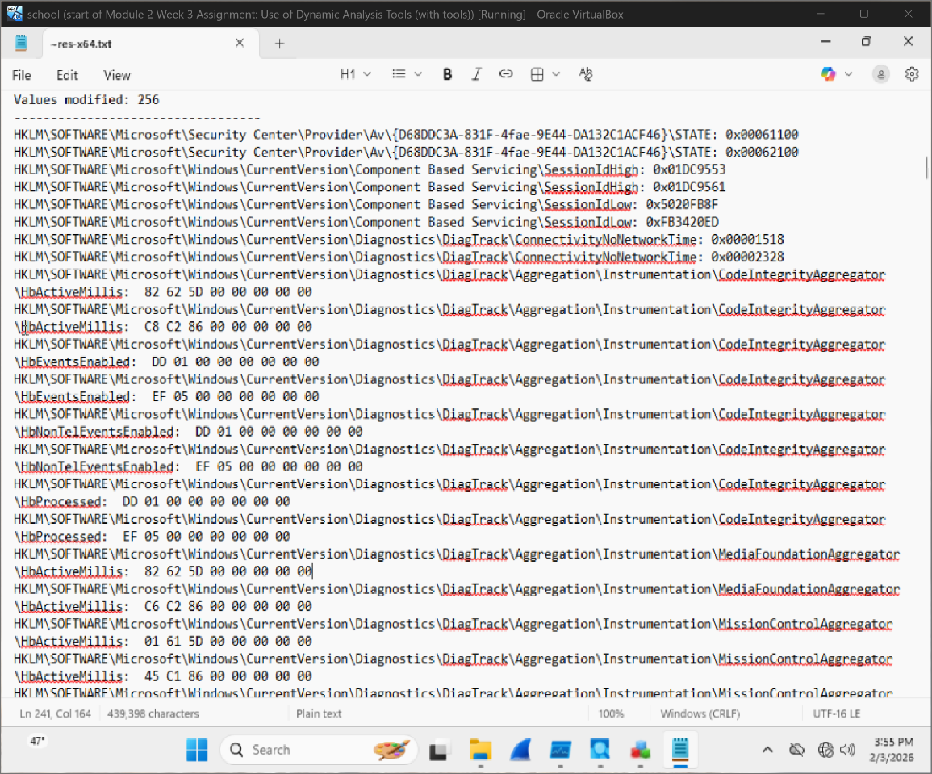

PROCmon
Set filter for PROCmon:
This screenshot shows the Process Monitor filter that was set up before the malware was run. The filter is set to only show activity from Lab03-01.exe and hide normal Windows processes. Windows runs a lot of background programs all the time and they can create a lot of events. Without a filter it would be very hard to see what the malware is doing. By filtering only Lab03-01.exe Procmon focuses on file activity, registry changes and process actions that come directly from the malware. This makes the results easier to read.
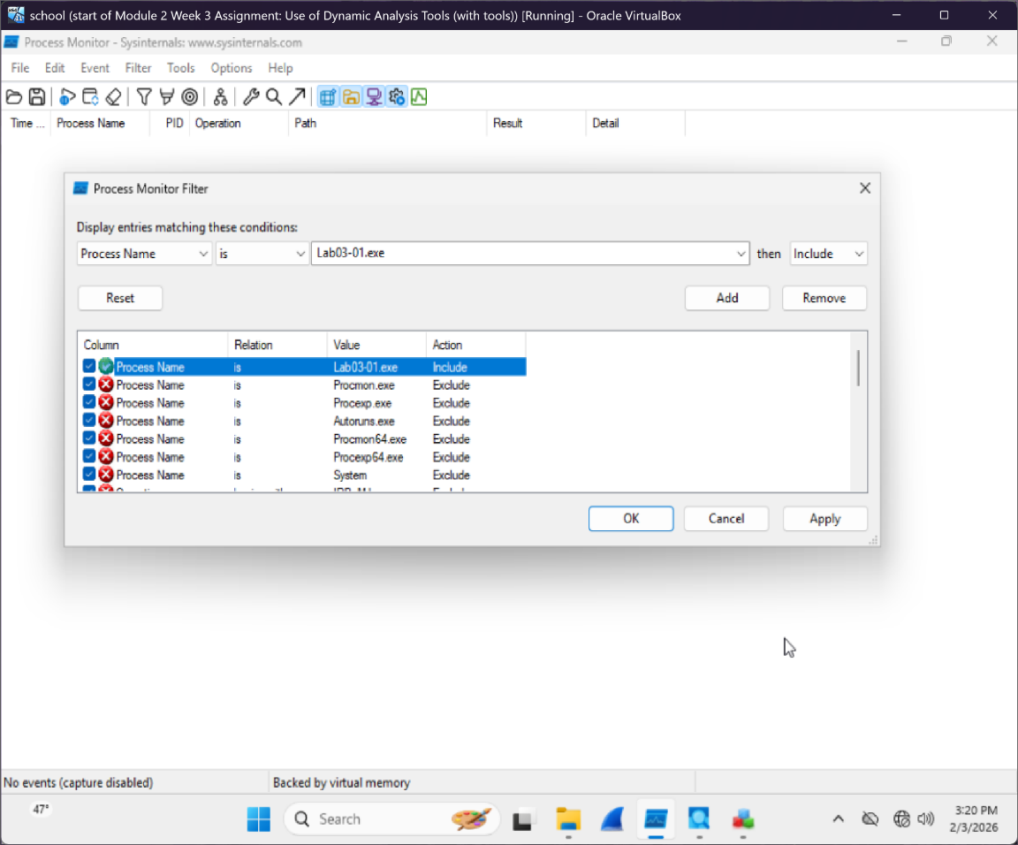

PROCmon basline (nothing running):
This screenshot shows the Procmon baseline before the malware was run. Procmon is open, but no events are being captured yet. It shows what the system looks like when it is idle. Having a blank starting point makes it easier to spot new activity later. Any events that appear after the malware runs can be linked to the malware instead of normal stuff.
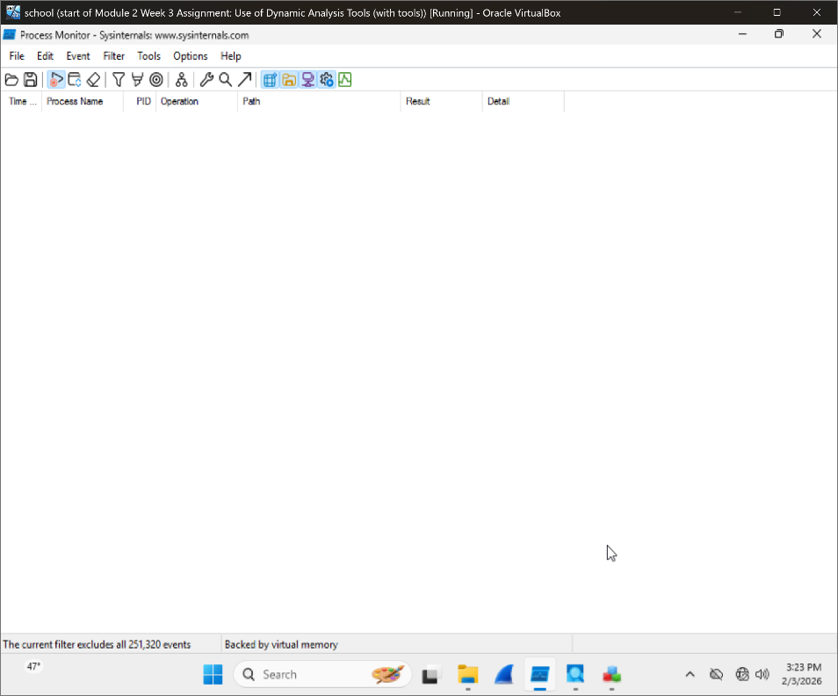

PROCmon malware running:
This screenshot shows Process Monitor while the malware is actively running. With the filter applied Procmon is only showing stuff running from Lab03-01.exe. During this the malware is reading files, opening registry keys, and interacting with system components. Seeing this activity in real time is important because it proves the malware did not just open and close. It actively interacted with the system while it was running. Procmon helps show exactly how the malware behaved, which files and registry locations it touched, and what actions it performed during execution.
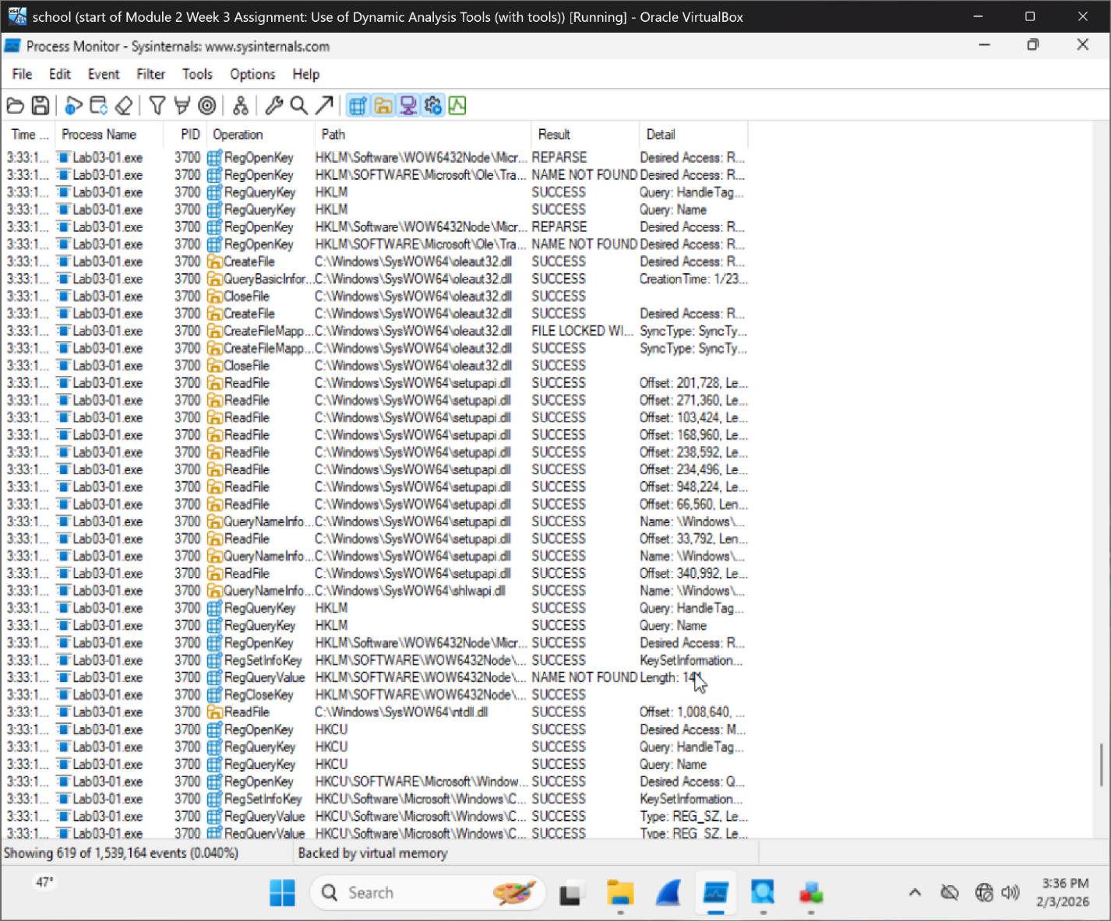

Process Explorer
This screenshot shows Process Explorer being used to see what programs are running on the system. Process Explorer lets you see active processes, how much memory they are using and how they relate to each other. Nothing looks strange or clearly malicious. Most of the processes shown are normal Windows programs like system services and user interface tools. This means the malware did not keep running in the background or hide as a long running process after it finished. Process Explorer is helpful because it shows if malware is still active or using system resources.
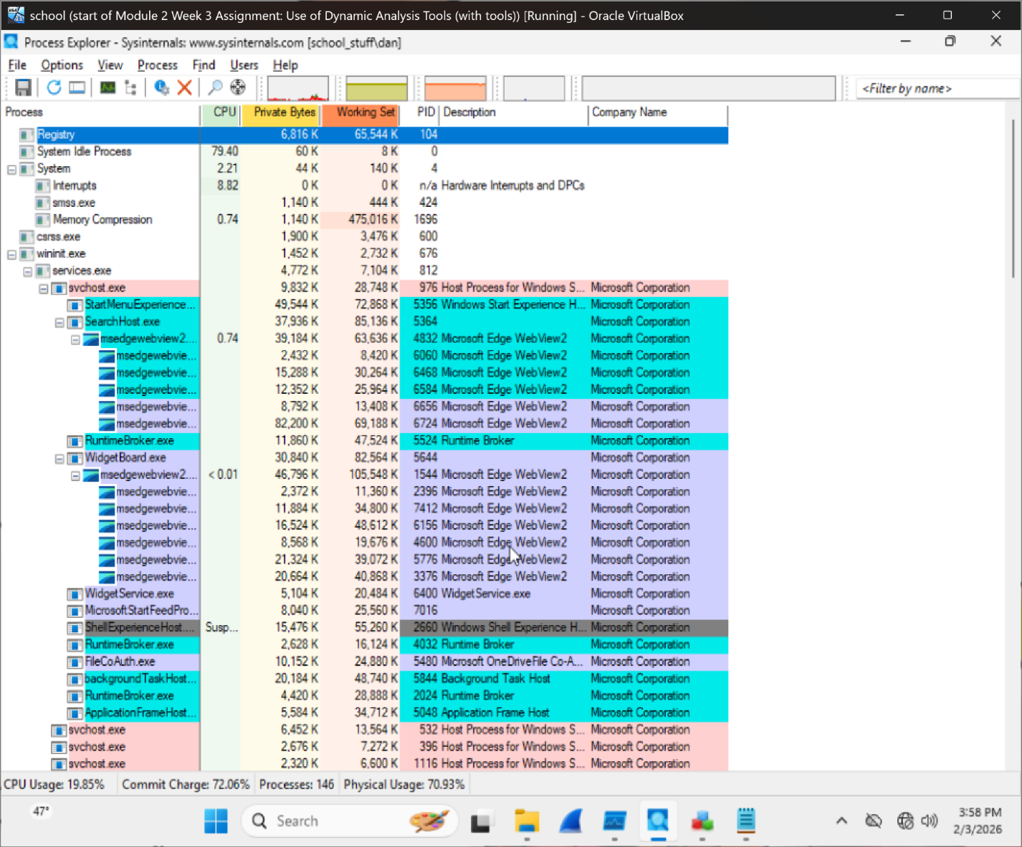

Findings
During this analysis, the malware was run inside a safe virtual machine using a host-only network adapter. This means the malware did not have accss to the real internet, which made the testing safer. The malware was watched using Regshot, Process Monitor, and Process Explorer. While running in this isolated setup, the malware added, changed, and deleted registry keys and values on the system.
Regshot showed clear registry changes after the malware ran, including deleted keys, deleted values, modified values, and newly added keys and values. These changes show that the malware actively interacted with system components while it was running.
Process Monitor confirmed that the malware accessed registry keys and system resources during execution. This showed that the malware did more than just open and close and that it did stuff on the system.
Process Explorer did not show any suspicious or long running malicious processes. This suggests that the malware did not remain active in memory and did not make a persistence through a visible running process.
The malware caused system changes during execution but did not demonstrate clear persistence mechanisms. But the registry activity confirms that the malware had an impact on the system and should not be considered harmless.

Risk Assessment
Based on the results of the dynamic analysis, this malware is considered a low to moderate risk. The malware did not show clear persistence methods like adding itself to startup registry keys or staying active as a background process. But the malware did modify the Windows registry and interacted with system resources when it was running. These actions could still cause problems like system problems, changes to system settings or be used as part of a larger attack. Even though the malware did not remain active after execution, it should not be considered safe. Running this malware on a real system could still lead to bad effects.
Reflection Questions
1. What types of registry changes could suggest persistence?
Registry changes that suggest persistence are changes that let malware start again after the computer restarts. This happens when malware adds itself to startup registry keys like Run or RunOnce. When this happens the malware can automatically run every time a user logs in.
2. What does it mean if files are created in %APPDATA%, %TEMP%, or hidden directories?
If files are created in folders like %APPDATA%, %TEMP%, or hidden directories, it can be sketchy. Normally, these folders are used by legitimate programs to store settings, temporary files, or data needed for apps to run correctly. Malware often uses these same locations because users do not check them very often. These folders can be used to store malicious files, temporary data or extra files without being easily noticed.
3. How might malware hide its presence using file attributes or naming?
Malware can hide by using file names that look normal or similar to real system files. It can also mark files as hidden or system and that makes them harder to see in File Explorer. These tricks help malware avoid attention while it runs or stores data on the computer.

Reference

Microsoft. (2023). Windows Registry. Microsoft Learn.
https://learn.microsoft.com/en-us/windows/win32/sysinfo/registry

Microsoft. (2020). Windows Error Reporting. Microsoft Learn.
https://learn.microsoft.com/en-us/windows/win32/wer/windows-error-reporting
Microsoft. Windows diagnostics and telemetry.
https://learn.microsoft.com/en-us/windows/privacy/windows-diagnostic-data
Sikorski, M., & Honig, A. (2012). Practical Malware Analysis. No Starch Press.

